ASSIGNMENT 1

|  |  |
| --- | --- |
| Student name | Swetha V |
| Register Number | 2019504596 |
| Maximum marks | 2 marks |

**Question:**

To make a smart home automation system with sensors learnt using TinkerCad

# Aim:

To design a smart home automation system using

primary sensors

# Software used:

TinkerCad

# Components required:

* Arduino Uno R3
* Smoke detector
* PIR sensor
* LDR sensor
* Ultrasonic sensor
* DC power source
* Relay

# Working:

* If someone enters inside the home, the Fan will beautomatically turned ON, which can also be controlled manually using switch.
* If LPG gas is leaked, the alarm circuit will get activated the buzzer will start buzzing.
* An Ultrasonic sensor will be set up on the top of the main door. The door will automatically open if anyone comes near to it.
* If the room is dark, the LDR sensor will activate and turns ON the bulb.

# CIRCUIT DIAGRAM:

**Before Simulation:**

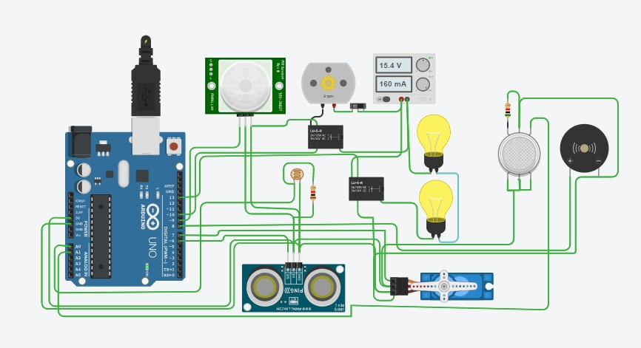

**After simulation:**

The bulb glows and the fan starts to rotate

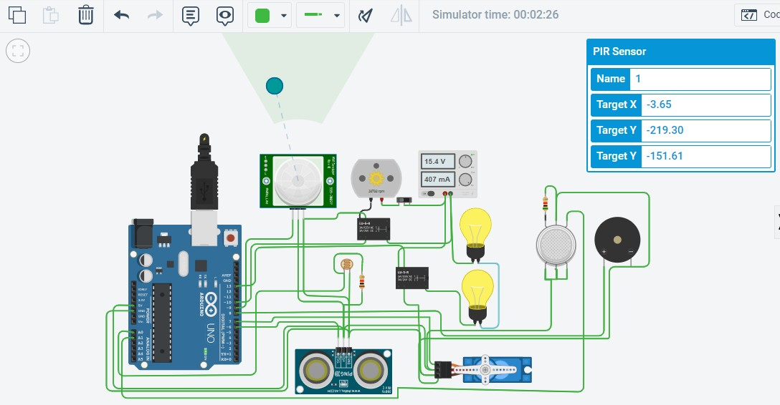

Leakage of LPG gas is detected

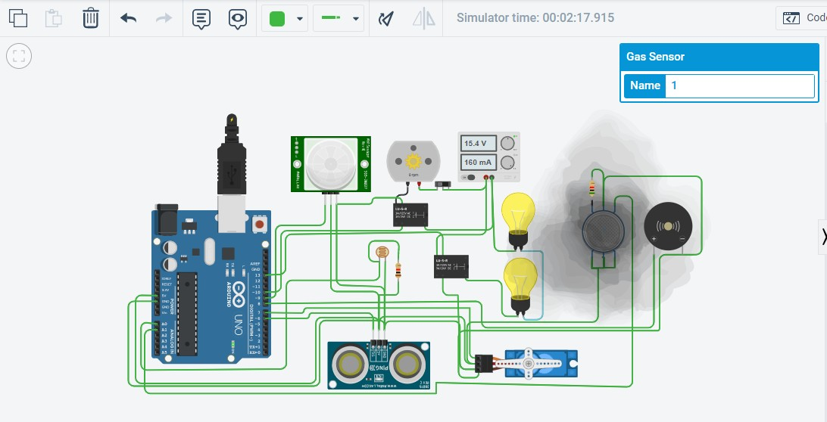

# CODE:

#include <Servo.h>

int output1Value = 0; int sen1Value = 0; int sen2Value = 0;

int const gas_sensor = A1; int const LDR = A0;

int limit = 400;

long readUltrasonicDistance(int triggerPin, int echoPin)

{

pinMode(triggerPin, OUTPUT); // Clear the trigger digitalWrite(triggerPin, LOW); delayMicroseconds(2);

// Sets the trigger pin to HIGH state for 10 microseconds digitalWrite(triggerPin, HIGH);

delayMicroseconds(10); digitalWrite(triggerPin, LOW); pinMode(echoPin, INPUT);

// Reads the echo pin, and returns the sound wave travel time in microseconds

return pulseIn(echoPin, HIGH);

}

Servo servo_7; void setup()

{

Serial.begin(9600); //initialize serial communication pinMode(A0, INPUT); //LDR pinMode(A1,INPUT); //gas sensor

pinMode(13, OUTPUT); //connected to relay servo_7.attach(7, 500, 2500); //servo motor

pinMode(8,OUTPUT); //signal to piezo buzzer pinMode(9, INPUT); //signal to PIR

pinMode(10, OUTPUT); //signal to npn as switch pinMode(4, OUTPUT); //Red LED

pinMode(3, OUTPUT); //Green LED

}

void loop()

{

//------light intensity control //

//--------------------------------------------------------------

int val1 = analogRead(LDR); if (val1 > 500)

{

digitalWrite(13, LOW); Serial.print("Bulb ON = "); Serial.print(val1);

}

else

{

digitalWrite(13, HIGH); Serial.print("Bulb OFF = "); Serial.print(val1);

}

//--------------------------------------------------------------

//------ light & fan control //

//--------------------------------------------------------------

sen2Value = digitalRead(9);

if (sen2Value == 0)

{

digitalWrite(10, LOW); //npn as switch OFF digitalWrite(4, HIGH); // Red LED ON,indicating no

motion

digitalWrite(3, LOW); //Green LED OFF, since no Motion detected

Serial.print(" || NO Motion Detected " );

}

if (sen2Value == 1)

{

digitalWrite(10, HIGH);//npn as switch ON delay(3000);

digitalWrite(4, LOW); // RED LED OFF digitalWrite(3, HIGH);//GREEN LED ON , indicating

motion detected

Serial.print(" || Motion Detected! " );

}

delay(300);

//---------------------------------------------------------------

// ------- Gas Sensor //

//---------------------------------------------------------------

int val = analogRead(gas_sensor); //read sensor value Serial.print("|| Gas Sensor Value = ");

Serial.print(val); //Printing in serial monitor

//val = map(val, 300, 750, 0, 100); if (val > limit)

{

tone(8, 650);

}

delay(300); noTone(8);

//--------------------------------------------------------------

//------- servo motor //

//-------------------------------------------------------------

sen1Value = 0.01723 * readUltrasonicDistance(6, 6);

if (sen1Value < 100)

{

servo_7.write(90);

Serial.print(" || Door Open! ; Distance = "); Serial.print(sen1Value);

Serial.print("\n");

}

else

{

servo_7.write(0);

Serial.print(" || Door Closed! ; Distance = ");

Serial.print(sen1Value); Serial.print("\n");

}

delay(10); // Delay a little bit to improve simulation performance

}

# RESULT:

Hence, a smart home automation system is designed using Tinkercad